SDV602
– Assessment 2 –
Dylan Fry

Table of Contents
1 Introduction 3
2 Purpose 3
3 Scope 3
3.1 Included 3
3.2 Out of scope 3
4 Project Plan 3
5 Intended Audience 4
6. Intended Usage 4
7 Software Requirements 5
7.1 Functional requirements 5
7.2 Non-functional requirements 6
7.3 System requirements 6
8 System Design 6
9 Storyboards 8

1 Introduction
This project is an application developed with Python, the FreeSimpleGUI library and the Matplotlib library. It is a data displaying and analysing tool which can be used by either one user locally or multiple users online. It also has the functionality of sending and receiving messages between users in the same room via an online database.

2 Purpose
This application aims to solve the problem of simple multi-user data displaying. This application will benefit anyone who is looking for a way to quickly view their data as a chart or to easily share their data with others and discuss it long distance all in one place.

3 Scope

3.1 Included
- Generating basic graphs from CSV or BSON data
- Connecting to remote data servers
- Storing usernames and hashed passwords on the database
- Sending, storing and receiving messages between users in the same DES session
- Loading local CSV data
- Sending, receiving and storing BSON data to a remote data server
- Appending data to an existing data source
- Deleting a data source
- Storing multiple data sources of the same type and switching which is being rendered
- Multithreading for DES sessions

3.2 Out of scope
- Utilising data types other than BSON, JSON and CSV
- Creating charts other than line, pie and bar
- Writing data to files
- Password locking sessions

4 Project Plan
The project is currently in the design phase.
Next, it will enter the implementation phase which will follow the stages of:
- Develop local mode functionality w/o GUI
- Expand to include remote mode functionality w/o GUI
- Implement the headless testing mode
- Attach a GUI for the local/remote modes
After this will be testing which will use the headless testing mode to make sure all functions in the application work correctly and also testing the GUI separately to ensure all parts are working correctly.

5 Intended Audience
This application will be used by anyone who wishes to quickly display their data as a chart. It will also be used by anyone looking to share data with others for discussion or other such group activities.
Specific user groups could include data analysis hobbyists, companies working with data metrics and teachers/students.

6. Intended Usage
Local Mode:
- Open application in local mode
- Select import data
- Select data file
- View data in chart
- Close application
Remote Mode – Create DES session – No account
- Open application in remote mode
- Create account
- Sign in
- Create DES session
- Select import data
- Select data file
- View data in chart
- Message in chat
- Close application
Remote Mode – Join DES session – No account
- Open application in remote mode
- Create account
- Sign in
- Search for name of DES
- Find desired DES session in list
- Join DES session
- View chart
- Message in chat
- Close application
Remote Mode – View multiple DES sessions – Account
- Open application in remote mode
- Sign in
- Open first DES session from list
- Move DES session window aside
- Open second DES session from list
- View charts
- Close second DES session window
- Open third and fourth DES session from list
- View charts
- Close application

7 Software Requirements

7.1 Functional requirements
The system must:
- be able to zoom in, zoom out and pan around DES charts.
- display a text description of the chart being displayed.
- allow for the active data source to be switched.
- manage user accounts.
- allow the user to browse available public DES sessions.
The system must allow users to join public DES sessions.
The system must allow users to create and delete DES sessions.
The system must manage live messaging between users by DES session.
The system must handle DES publicity.
The system must allow for data to be uploaded to a remote server.
The system must handle missing data gracefully.
The system must have a GUI for interacting with and exploring data.
The system must have a local, remote and testing mode.
The system must hash passwords before they are sent to the server.
The system must have a headless testing mode which runs through all reasonable functionality, inputs and edge cases without opening the GUI.
The system must set its launch mode via command line arguments when it is launched.
The system must take sub-arguments depending on the launch mode.
The system must be able to support multiple DES in parallel using threads.
The system must bypass messaging and DES selection when launched in local mode.
The system must be able to append new data to an existing data source.
The system must be able to load data from a remote server.
The system must be able to load data from the local disk.
The system must only list publicly available sessions in the DES selection screen.
The system must allow for the chart to be configured within each DES.
The system must display data correctly.

7.2 Non-functional requirements
The system should load data at a rate equal to 1 second per 500 data points.
The system should only send absolutely necessary data across the network.
The system should not store any plaintext passwords or other such important information.

7.3 System requirements
The system will run on any system supporting the Python programming language (Windows, MacOS and Linux).
The system will use Python 3.14.
The system will use the FreeSimpleGUI and Matplotlib Python libraries.

8 System Design
Sign Up Screen
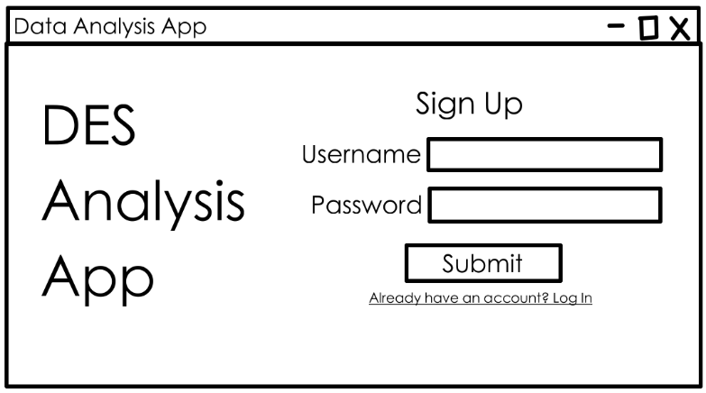
Login Screen
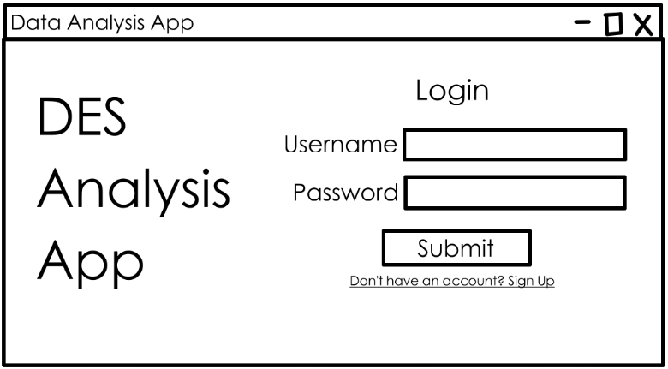
DES Screen
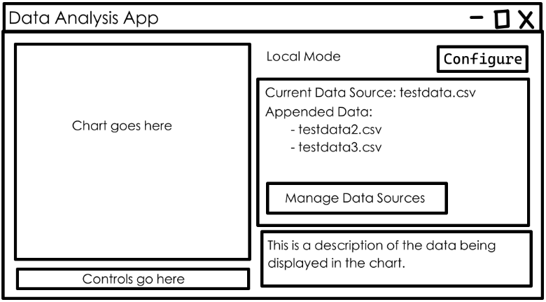
DES Session Selection Screen
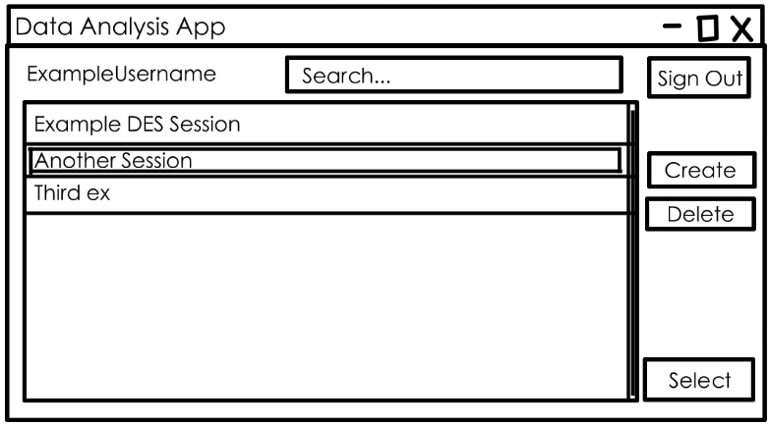
Chat Window
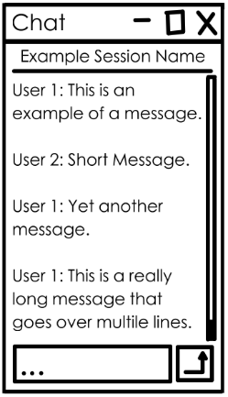
Data Source Management Screen
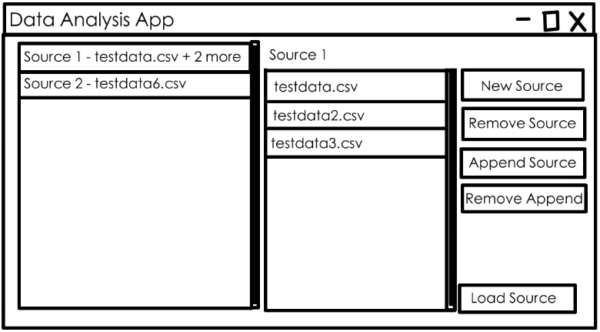
DES Session Creation Screen
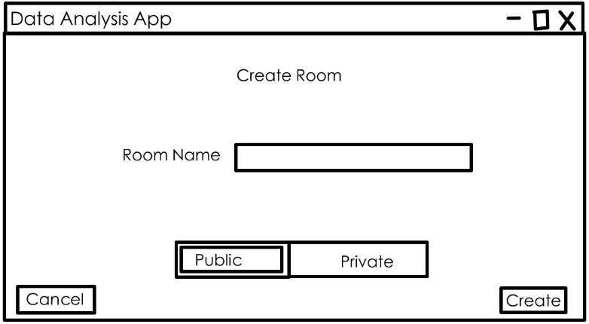
DES Config Screen
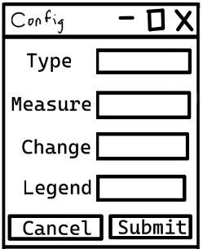

9 Storyboards
- Sign Up Screen | - Text Input – Takes in a username string.  - Text Input – Takes in a password string. Displays * instead of typed characters.  - Button – Attempts to create a new user on the database with the given username and password. If the account creation fails, a message box will popup to tell the user what went wrong. I it succeeds then the user will be taken to storyboard 3 as their new account.  - Button – Takes the user to storyboard 2.
4.
3.
1.
2.
- Login Screen | - Text Input – Takes a username input string.  - Text Input – Takes a password input string. Displays as * instead of actual characters.  - Button – Attempts to find the given username in the database and then checks if the password hashes match. If either of these fail, a popup message will tell the user that something went wrong. If the account exists and the passwords are correct, take the user to storyboard 4.  - Button – Take the user to storyboard 1.
4.
3.
2.
1.
- DES Screen | - Image – Displays the chart for the currently selected data source or a placeholder if no valid data exists.  - Buttons – The control panel for graph, uses Matplotlib’s built in controls.  - Text – Displays the user’s current mode for clarity.  - Button – Opens storyboard 8 in  - Button – Takes the user to storyboard 6.  - Text – Displays a brief description of the data in the chart.  - Text – Displays the currently loaded data sources.
7.
6.
5.
4.
3.
2.
1.
- DES Session Selection Screen | - Text – Shows the user’s name for clarity.  - Text Input – A search box to filter the DES session list by name.  - Button – Shows a yes/no confirmation popup. If yes, takes the user back to storyboard 2.  - Button – Sets the currently selected session when clicked.  - Button – Highlights the currently selected session.  - Scroll Bar – Scrolls through the DES session list.  - Button – Takes the user to storyboard 7.  - Button – Only shows if the selected session was created by the current user. When clicked, displays a yes/no confirmation popup. If yes, remove the selected session from the database.  - Button – Opens storyboard 3 and storyboard 5 in separate windows, loading the data from the database for the selected session.
9.
8.
7.
6.
5.
4.
3.
2.
1.
- Chat Window | - Text – Display the current session which the chat is for.  - Scroll Bar – Scrolls up and down the chat log.  - Multi-line Text – Displays the messages pulled from the server for the current session.  - Button – Sends a message to the server and adds it to the database.  - Text Input – Takes a message string.  Note: This windows closes only if the accompanying DES session window closes.
5.
4.
3.
2.
1.
- Data Source Management Screen | - Button – Selects a data source to load into the DES.  9.  - Scroll Bar – Scrolls through the data source list.  - Text – The name of the selected data source.  - Button – Shows each file that has been added to the selected data source.  - Scroll Bar – Scrolls through the data files.  - Button – Creates a new data source.  - Button – Removes the selected data source.  - Button – Opens a file selection system window to load a new file into the data source.  - Button – Removes the selected data file from the data source.  - Button – Returns to storyboard 3, loading the selected data source.
5.
6.
7.
8.
10.
4.
3.
2.
1.
- DES Session Creation Screen | - Text Input – Takes in a session name string.  - Button (Toggle) – Switches the session to public so it can be seen by others.  - Button (Toggle) – Switches the session to private so it can only be seen by the current user.  - Button – Returns to storyboard 4.  - Button – Creates a new session in the database and goes to storyboard 3 with the new session.
5.
4.
3.
2.
1.
- Config Screen | - Dropdown – Changes the DES chart type between a given set of options.  - Dropdown – Selects which column of the given data will be used as the measurment (y) axis.  - Dropdown – Selects which column of the given data will be used as the change (x) axis.  - Dropdown – Selects which column from the data will be used for the charts legend.  - Button – Closes the window.  - Button – Closes the window and applies the given values to the DES chart.
6.
5.
4.
3.
2.
1.

